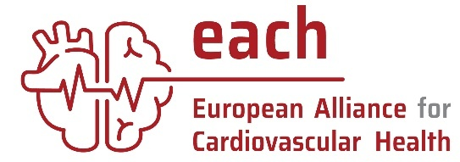
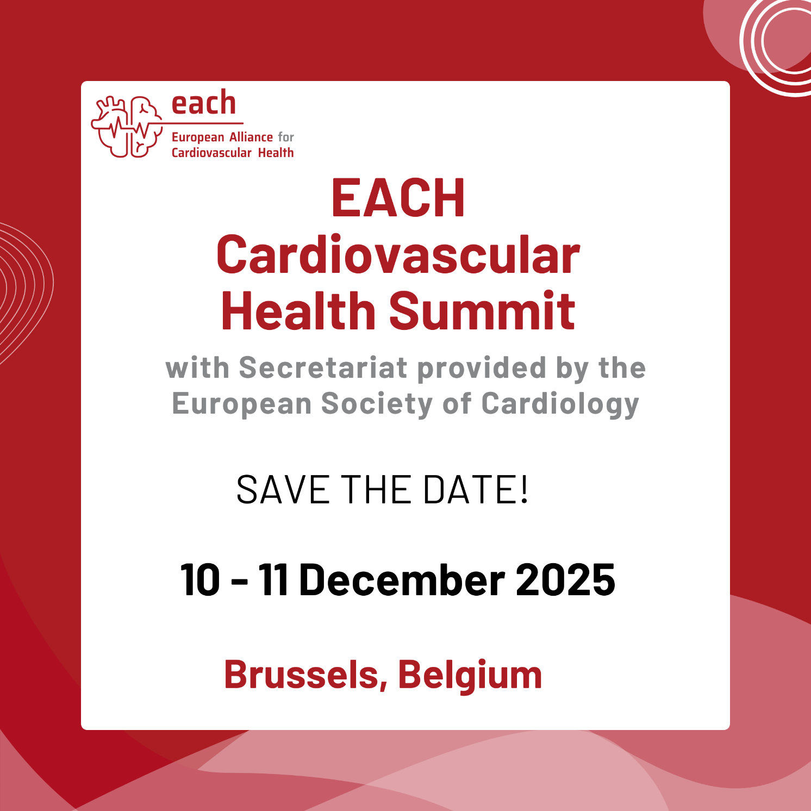

10-11 December, Brussels
PROGRAMME
Day 1 12:00 – 17:00
Time | Session
11:00 – 12:00 | Registration
12:00 – 12:05 | Welcoming remarks
12:05 – 12:30 | Opening keynote address by Commissioner Varhleyi: The EU Cardiovascular Health Plan
12:30 – 13:15 | Reflections from the MEP Cardiovascular Health Group, Chaired by Romana Jerkovic
13:15 – 14:15 | Speed-networking lunch
14:15 – 14:45 | Science-snippets:  - Hearts & minds: How does cardiovascular disease affect mental health, and vice versa?  - How does the environment around us affect our risk for cardiovascular disease?
14:45 – 15:45 | High-level panel: addressing inequalities and improving equity through EU and national cardiovascular health action plans
15:45 – 16:15 | Coffee break
16:15 – 16:45 | Spotlight on: cardiovascular health in Denmark
16:45 – 17:00 | Closing remarks
17:00 – 18:30 | Networking reception

Day 2 09:00 – 13:00
Time | SESSION
08:00 – 09:00 | Registration
09:00 – 09:45 | Science, research and innovation focused panel
09:45 – 10:30 | Patient experience panel
10:30 – 11:00 | Networking break
11:00 – 11:15 | Science-snippet:  Gender differences in CVD – taking a fresh look at improving inequalities
11:15 – 11:45 | Learnings from the cancer field
11:45 – 12:30 | Key takeaways panel:  Keeping the EU competitive through improving and investing in cardiovascular health
12:30 – 12:45 | Closing remarks
12:45 – 14:00 | Networking lunch
